x4to1XTRXv13 Gerber files definition:
Silk TOP - x4to1XTRXv13.GTO
Mask TOP - x4to1XTRXv13.GTS
TOP Layer - x4to1XTRXv13.GTL
Internal 1 – x4to1XTRXv13.G1
Internal 2 – x4to1XTRXv13.G2
BOTTOM Layer – x4to1XTRXv13.GBL
Mask BOTTOM – x4to1XTRXv13.GBS
Boarder – x4to1XTRXv13.GKO
NC drill:
“Top to Bottom” - plated – x4to1XTRXv13-Plated.TXT
“Top to Bottom” - non-plated – x4to1XTRXv13-NonPlated.TXT
Physical PCB Layers structure (for example):
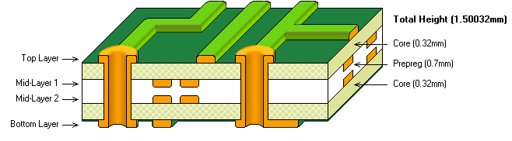
Outer Layer Copper Thickness 1oz/35μm
Inner Layer Copper Thickness 1oz/35μm
Overall Size - 100 x 70 mm ± 0.25 mm.
Finishing – gold plating, minimum thickness of 30 micro-inches for Edge Connector finger tabs and minimum 4 micro-inches for entire board.
Edge connector thickness – 1.5 mm ± 0.1 mm.
Facets – 20° \|/ 20° x 1.4 mm for edge connector

© Fairwaves Inc., 2018.

